All about

Date …………………………………………

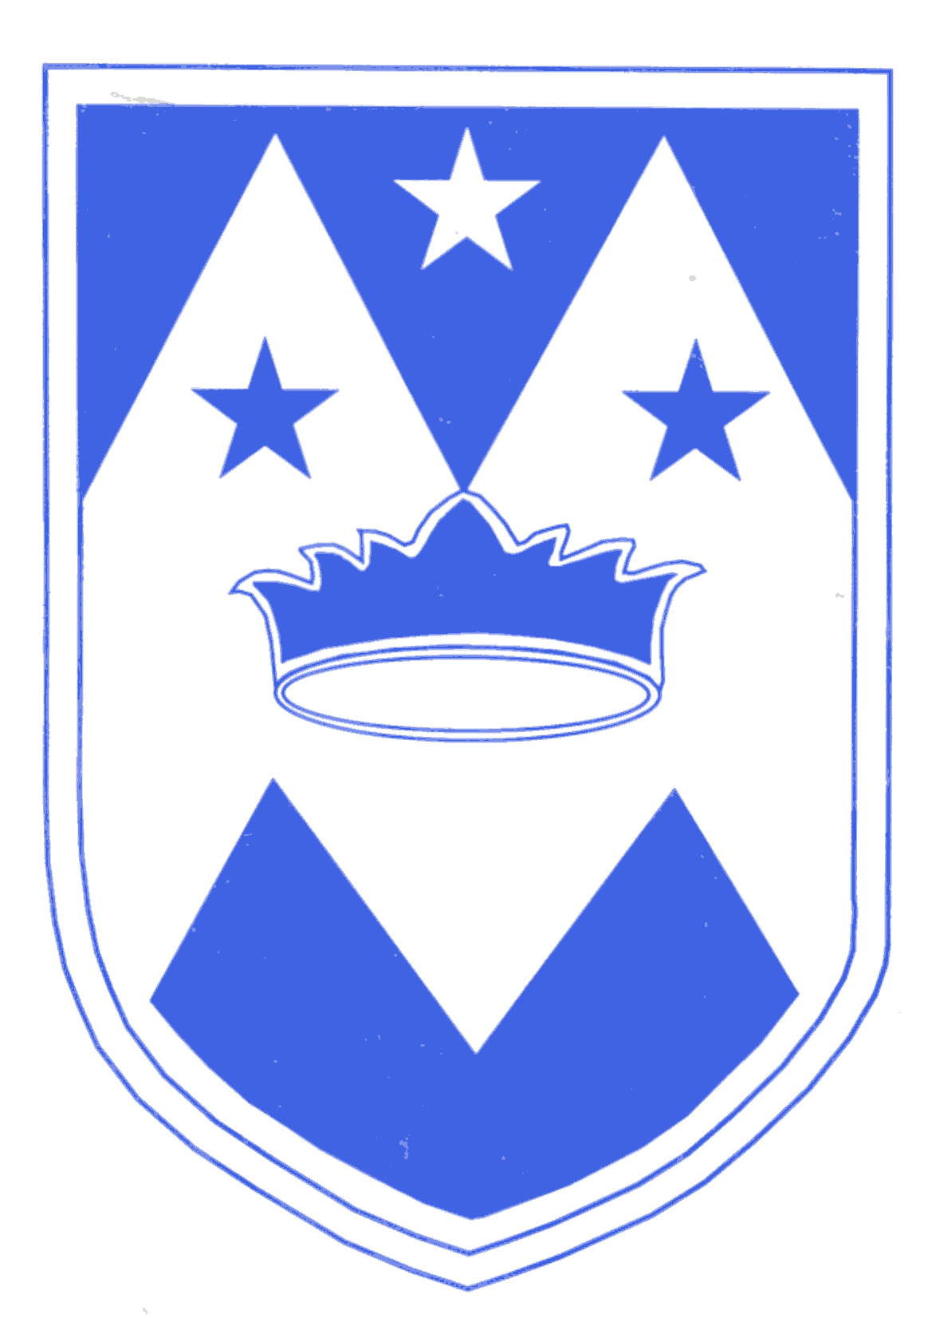

Self Portrait

This is a picture of me

My family

In my family there is ……………………………………………………………………………………………………………………………..………………………………………………………………
……………………………………………………………….
My favorite things
Colour the star in your favorite colour.

Draw your favorite food on the plate.
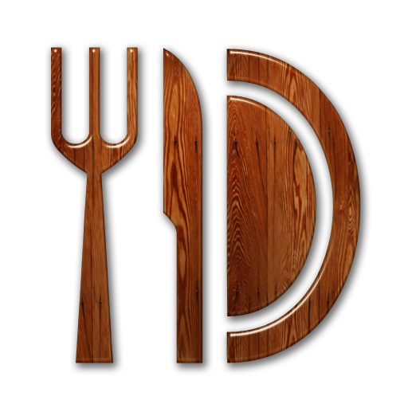

Draw a picture of your favorite toy.

What is your most favorite thing to do?

All about …………………………………………….

My birthday is……………………………………

My hair is……………………………………………

My eyes are………………………………………..

There are ……… candles on my cake.

Thank you for
completing this
booklet and
welcome to St Maries
Reception Class!

