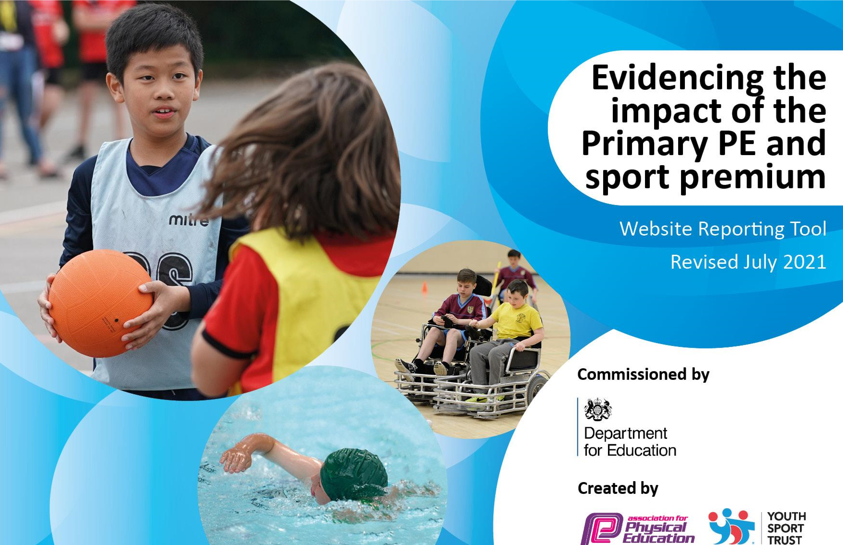
St Marie’s Catholic Primary School 2022 - 2023

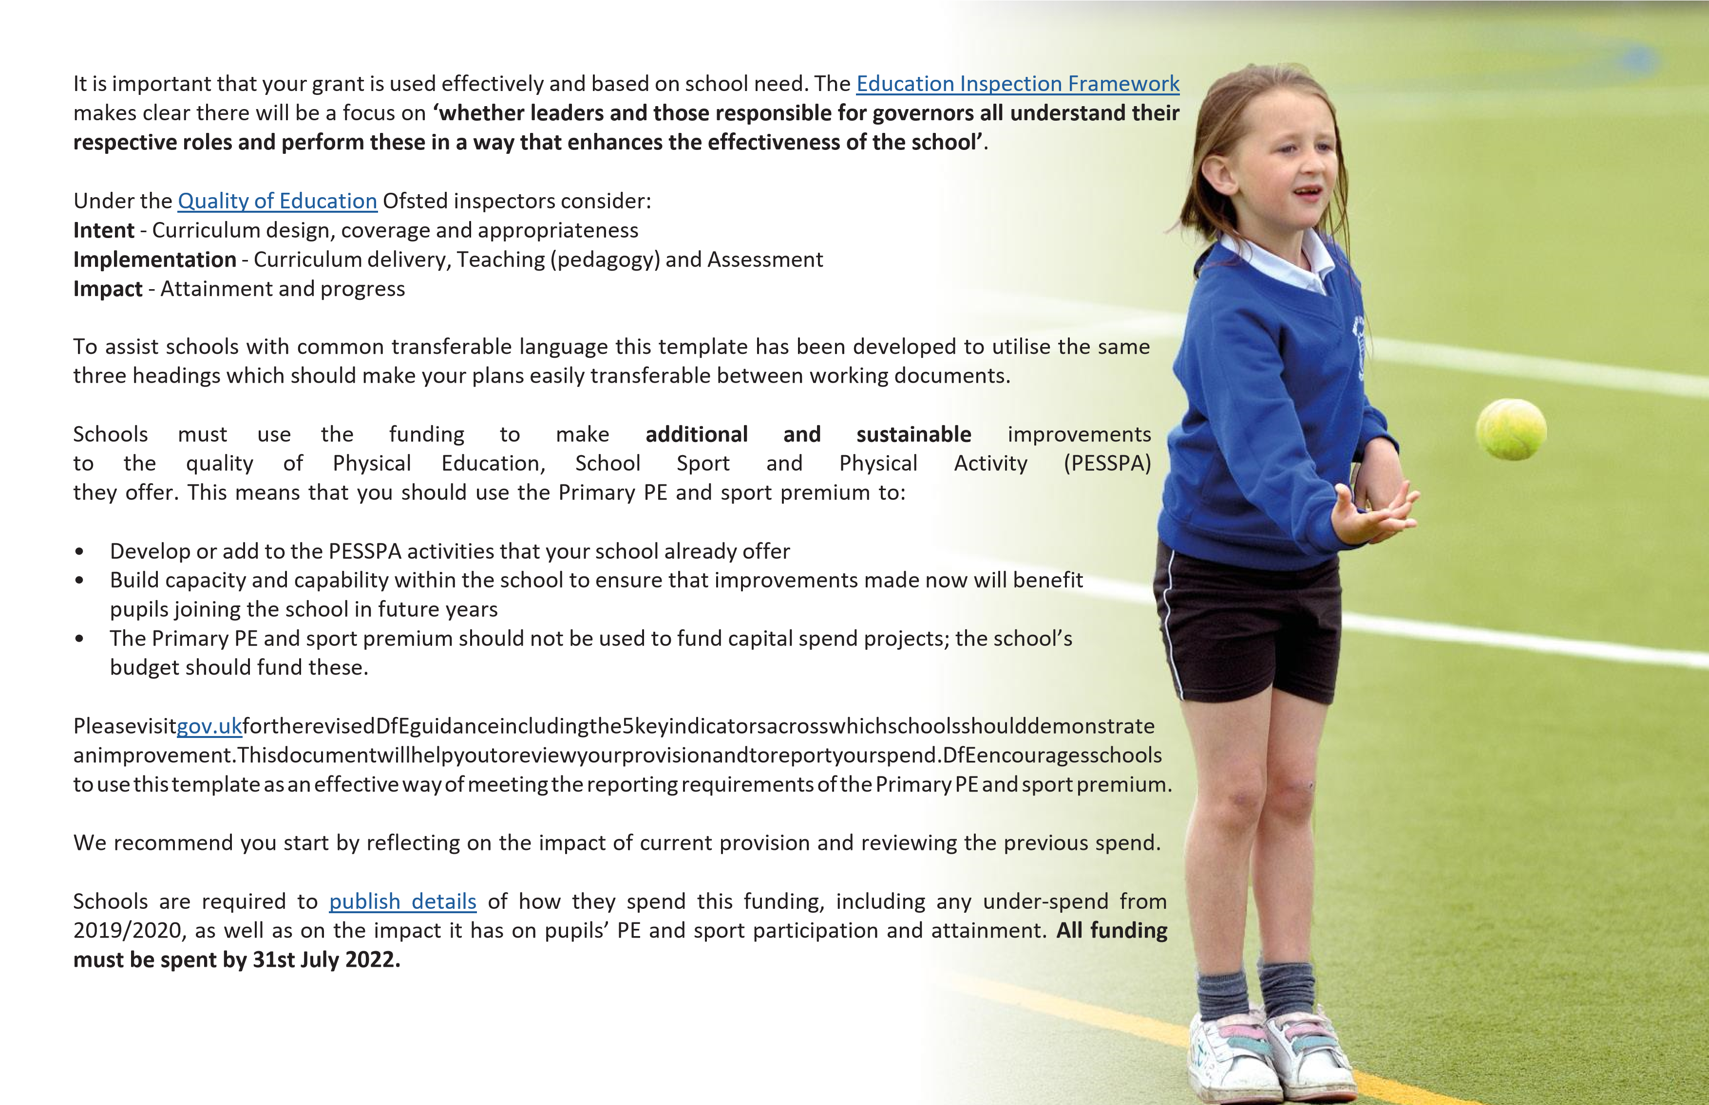
We recommend regularly updating the table and publishing it on your website throughout the year. This evidences your ongoing self-evaluation of how you are using the funding to secure maximum, sustainable impact. Final copy must be posted on your website by the end of the academic year and no later than the 31st July 2021. To see an example of how to complete the table please click HERE.
Created by: Supported by:

Details with regard to funding
Please complete the table below.

Total amount carried over from 2020/2021 | £0
Total amount allocated for 2021/2022 | £18,000
How much (if any) do you intend to carry over from this total fund into 2021/2022? | £0
Total amount allocated for 2022/2023 | £17,710
Total amount of funding for 22/23. To be spent and reported on by 31st July 2023. | £17,710

Swimming Data
Please report on your Swimming Data below.

Meeting national curriculum requirements for swimming and water safety.

N.B. Complete this section to your best ability. For example you might have practised safe self-rescue techniques on dry land which you can then transfer to the pool when school swimming restarts.
Due to exceptional circumstances priority should be given to ensuring that pupils can perform safe self rescue even if they do not fully meet the first two requirements of the NC programme of study
What percentage of your current Year 6 cohort swim competently, confidently and proficiently over a distance of at least 25 metres?  N.B. Even though your pupils may swim in another year please report on their attainment on leaving primary school at the end of the summer term 2020. Please see note above | 72%
What percentage of your current Year 6 cohort use a range of strokes effectively [for example, front crawl, backstroke and breaststroke]? Please see note above | 72%
What percentage of your current Year 6 cohort perform safe self-rescue in different water-based situations? | 80%
Schools can choose to use the Primary PE and sport premium to provide additional provision for swimming but this must be for activity over and above the national curriculum requirements. Have you used it in this way? | Yes/No

Action Plan and Budget Tracking
Capture your intended annual spend against the 5 key indicators. Clarify the success criteria and evidence of impact that you intend to measure to evaluate for pupils today and for the future.

Academic Year: 2022/2023 | Total fund allocated: 17,710 | Date Updated: July 2023
Key indicator 1: The engagement of all pupils in regular physical activity – Chief Medical Officers guidelines recommend that primary school pupils undertake at least 30 minutes of physical activity a day in school |  |  |  | Percentage of total allocation:
 |  |  |  | 28%
Intent | Implementation |  | Impact | Sustainability and suggested next steps
To give the children the opportunity for competitive sports through school competitions in a wide variety of sports/ games in partnership with the KSSP | To encourage children to participate in inter school competitions locally by partnering up with KSSP  Getting children more physically active and raising the profile of sport at break and lunch times employed coach to bring in a range of different activities for each Key Stage  Employment of specialists for PE Football and Gymnastics, Dance coaches providing dance techniques form other cultures  Continue to develop and use whole school plans and assessment. Use 5 a day sports to raise attainment at each year group  Continued purchasing LFC Foundation programme to ensure the progression and continuity of teaching and learning  Through PE lessons with specialist  (team teach with class teacher)  Walk to school take up encouraged | £1350.00  £2,100.00  £2825.00  £3000.00 | Children achieve the School Games Award as a result of this participation. Pupils are practicing and developing skills encouraging them to seek further sporting opportunities outside of school  More children enjoy a range of physical activity, increase number of pupils participating in a range of difference sports and enjoy them.  Increase in participation - development physically and supporting good mental health.  High quality teaching and learning will provide pupils with greater opportunities to develop their skills in sport.  Staff deliver high quality teaching and good subject knowledge  Daily exercise is incorporated into children’s daily lives | Celebration of competition participation at assemblies and through communications with the wider school community.  Increase in participation - development physically and supporting good mental health.  Development of a coaching position to support a fully comprehensive PE curriculum throughout the school.

To enable all pupils to take part in different areas of PE that include. Teambuilding, resilience, and orienteering.  To impact upon pupils’ social emotional and physical wellbeing | Outdoor experiences to develop leadership skills and teamworking, through a range of outdoor activities | £5101.00 | Improved emotional well being,
Key indicator 2: The profile of PESSPA being raised across the school as a tool for whole school improvement |  |  |  | Percentage of total allocation:
Intent | Implementation |  | Impact
Pupils received two PE lessons per week  Sports Day promoting team sports, demonstrating skills learnt through the year and progress made.  All Staff have a good subject knowledge. | Delivered by teacher and 1 delivered by sporting coach.  Pupils becoming more active and involved in a wide variety of different types of sport  Staff are up to date on their subject knowledge  Sports Day delivered by employed sports coaches and teaching staff | Funding allocated:  £500.00 | Attainment is raised through out school.  Increase in skills as team players and sportsmanship  Children enjoy and love participating in sport.  Children take up more sporting activities and physical exercise outside of school | -Achieve more awards from outside agencies to allow the children to be proud of their school –ensure we achieve School Games Award

Key indicator 3: Increased confidence, knowledge and skills of all staff in teaching PE and sport |  |  |  | Percentage of total allocation:
 |  |  |  | 20%
Intent | Implementation |  | Impact
 |  | Funding | Evidence of impact: what do | Sustainability and suggested
Staff questionnaire to help develop skills gap  To raise enjoyment and attainment  in PE and Sport through encouraging staff  Change from one staff member  leading PE to a team of staff members  Range of resources available to staff to help them teach and prepare lessons. | Staff to observe and team teach with LFC Foundation  All staff to be given the opportunity to be part of sporting fixtures both during and after school  All staff who show an interest in the running of school sport to be part of a team of teachers | allocated:  £774.00 | pupils now know and what Teacher’s questionnaires completed before and after each term  Pupil voice meetings held with school council | next steps:  Provide CPD opportunities to develop teachers skills and confidence – identified by the skills assessment  School Council to capture children’s opinions and suggestions to develop the PE offer

Key indicator 4: Broader experience of a range of sports and activities offered to all pupils |  |  |  | Percentage of total allocation:
Intent | Implementation |  | Impact
Offer additional opportunities to pupils to take part in physical activity and sport. Provide additional links via online and remote learning.  Deliver a broader curriculum and offer new sports . | LFC Red Neighbours after school clubs through out the year offered to different year groups  On-line physical activities offered by 5 a day sport which can be accessed in the class room  Relevant staff given time out of class to organise sporting events, registers and kit  Pupils attend competitions  (where possible)  Deliver a broad range of sports on the long term plan, so pupils are getting opportunity to try new sports and find something they enjoy  Purchasing specialist equipment and teaching resources to develop  a fully broad and inclusive  curriculum | £670.00 | Evidence of what pupils now know what they can do now?  What has changed  100% pupils participated in some kid of new sport (either during lockdown videos sent from our specialist PE teacher or during PE lessons at school)  Pupils remained interested in PE throughout the year and uptake for the online programme w. | Sustainability and suggested  Next steps  Encourage parents to enrol children in out of school sports clubs (where possible)  Encourage parents to take children swimming out of school hours (when pools reopened

Additional achievements: |  | £

Key indicator 5: Increased participation in competitive sport |  |  |  | Percentage of total allocation:
 |  |  |  | 11%
Intent | Implementation |  | Impact
 |  | Funding | Evidence of impact: what do | Sustainability and suggested
 |  | allocated: | pupils now know and what can they now do? What has changed?: | next steps:
Inclusive participation for all pupils to participate  Provide more opportunities for pupils to attend competitions/festivals | Participating is more competitive opportunities.  Support access to those opportunities by providing transport  Providing equipment to support children with SEN or a physical disability to participate | £ 1390 | Pupils who would not normally attend do so as the barrier to access has been removed.  Increased levels of sportsmanship, reduction in behavioural incidents as a result  All pupils can actively engage in sport | Development of sports coach role that will improve all children’s basic skills.  Sports coach will develop a comprehensive program of extra curriculum activities open to all.  A range of team representing a wide range of sports than previous.  Development of OPAL (Outdoor Play and Learning) to increase and develop play opportunities for children through physical development.

Signed off by
Exec Head Teacher: | Mr M White
Date:
Subject Leader: | CFTreanor
Date:
Governor:
Date:

