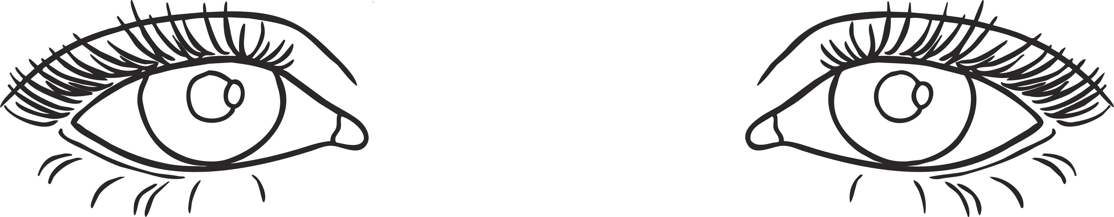
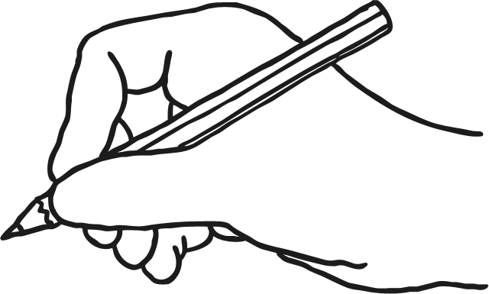
Look and Say
Look, Say
and Write
Cover
and Write
the
that
not
look
Look and Say
Look, Say
and Write
Cover
and Write
the
that
not
look

Look and Say
Look, Say
and Write
Cover
and Write
the
that
not
look

