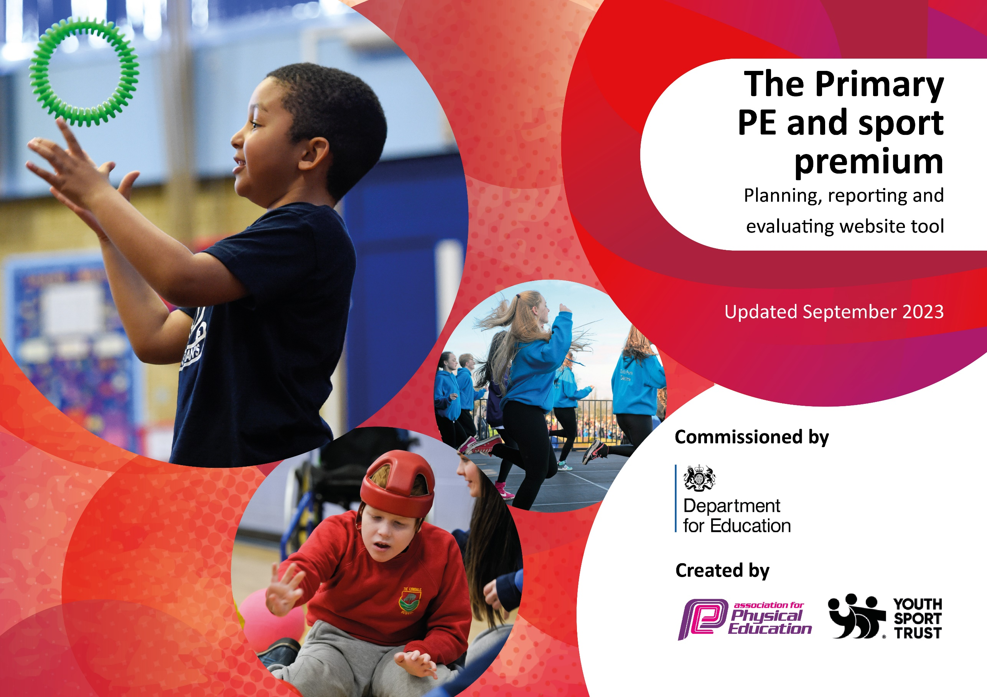

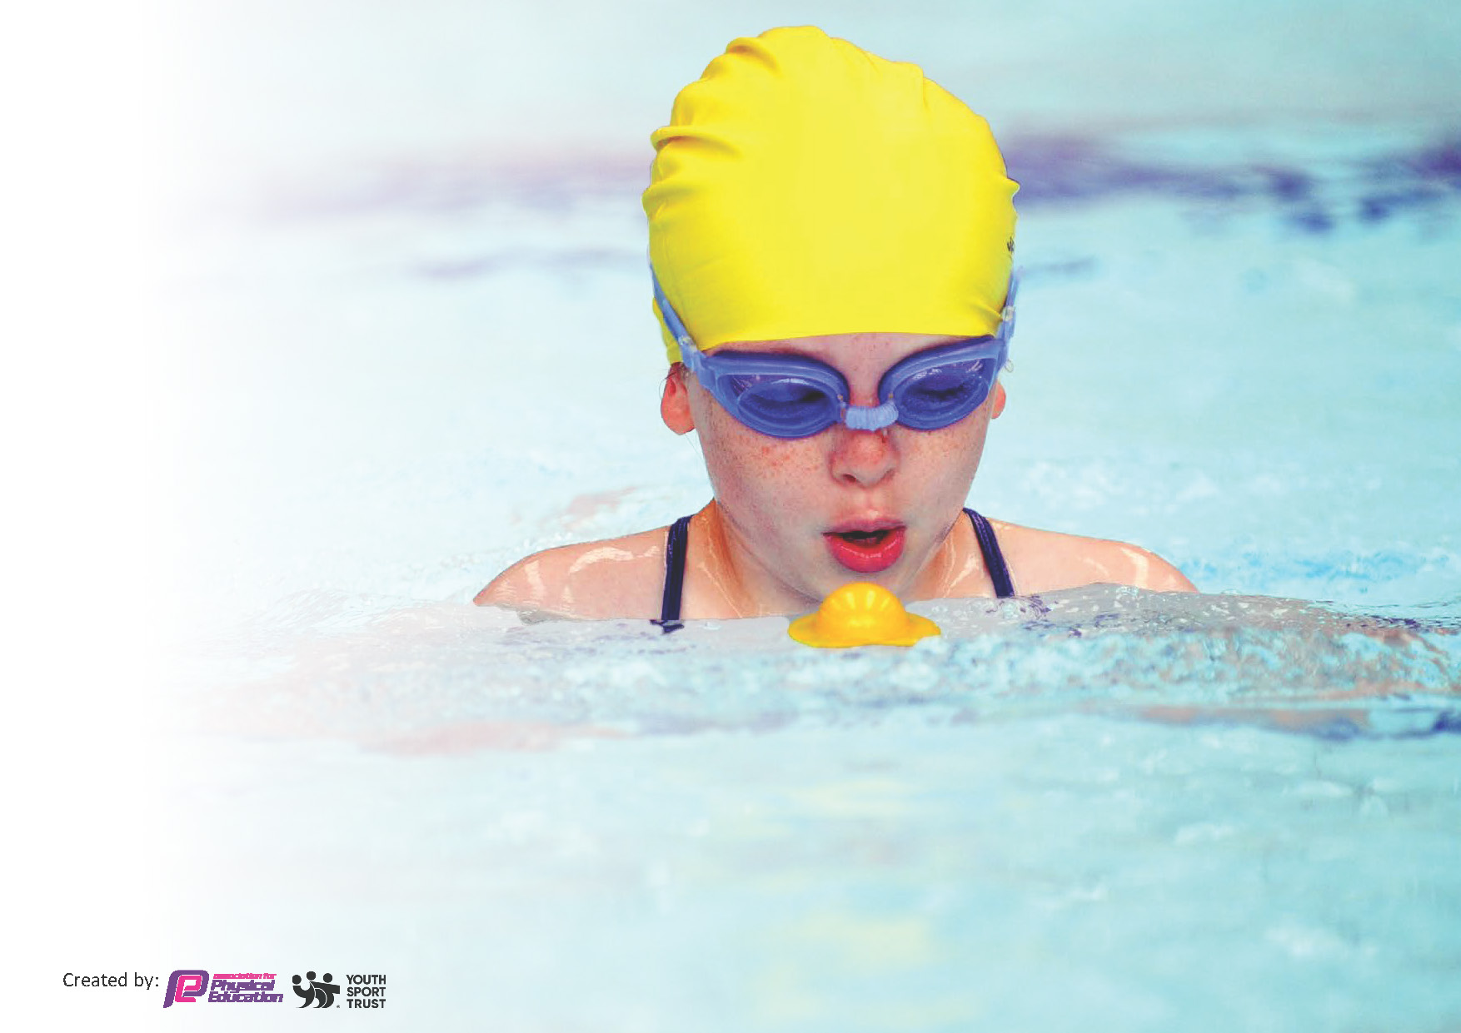
This template can be used for multiple purposes:
by:
- It enables schools to effectively plan their use of the Primary PE and sport premium
- It helps schools to meet the requirements (as set out in guidance) to publish information on their Primary PE and sport premium
- It will be an effective document to support Ofsted inspections enabling schools to evidence progress in Physical Education (PE) and evidence swimming attainment, which forms part of the PE National Curriculum. We would recommend schools consider
the Intent, Implementation and Impact of any spend, as examined within the Education Inspection Framework.

It is important that your grant is used effectively and based on school need.

Schools must use the funding to make additional and sustainable
improvements to the quality of the PE, School Sport and Physical Activity (PESSPA)
they offer. This means that you should use the Primary PE and sport premium to:

- Build capacity and capability within the school to ensure that improvements made now will benefit pupils joining the school in future years
- Develop or add to the PESSPA activities that your school already offers.

The Primary PE and sport premium should not be used to fund capital spend projects; the school’s core budget should fund these. Further detail on capital expenditure can be found in the updated Primary PE and sport premium guidance.

The Primary PE and sport premium guidance, outlines 5 key priorities that funding should be used towards. It is not

necessary that spending has to meet all the key priorities, you should select the priorities that you aim to use any funding towards.

Although completing this template is not a requirement for schools, schools are required to publish details of how they spend this funding. Schools must also outline what the impact this funding has had on pupils’ PE and sport participation and attainment and how any spending will be sustainable in the future. All funding must be spent by 31st July 2024.

The Department for Education has worked closely with the Association for Physical Education (afPE) and the Youth Sport Trust (YST) to develop this template and encourages schools to use it. This template is an effective way of meeting the reporting requirements of the Primary PE and sport premium.
Review of last year’s spend and key achievements (2022/2023)

Key priorities and Planning
This planning template will allow schools to accurately plan their spending.

Action – what are you planning to do | Who does this action impact? | Key indicator to meet | Impacts and how sustainability will be achieved? | Cost linked to the action
Give children the opportunity for competitive sports through school competitions in a wide variety of sports/games in partnership with KSSP.  Getting children more physically active and raising the profile of sports at break and lunch times by having a coach available for all Key Stages.  Develop a range of resources available to staff to help them teach and prepare lessons beyond the curriculum including break/lunch and extra-curricular activities. Deliver a broad curriculum and offer new sports. Pupil receive two PE lessons per week.  Increase children’s active travel to school.  Sports Day promoting team sports, demonstrating skills learnt through the year and progress made.  All staff to have good subject knowledge.  Event day to introduce a new sport (Quidditch).  Playground servicing for children’s outdoor exploration.  OPAL  Employment of a sports coach to broaden the sports opportunities for children. | All teaching staff who will attend. SLT for external competitions. PE lead (AA) to organize. Sports coach (CM) to transport and manage.  Pupils – as they will take part.  SLT to employ and guide Active Sports Group. Welfare staff to support the activities at lunch.  Sports coach to deliver active OPAL activities.  All staff to deliver.  Sports coach.  Pupils.  Pupil participation  All staff tracking travel.  PE Lead to hold assembly.  Sports Coach and PE lead plan and delivery.  All staff supporting.  Staff are updating subject knowledge through CPD/Staff meetings.  All staff and pupils taking part. CPD opportunity.  Business Manager.  OPAL Lead.  SLT to recruit.  Business manager.  PE Lead | Key indicator 4: Broader experience of a range of sports and activities offered to all pupils.  Key indicator 5: Increase participation in competitive sports.  Key indicator 2: Engage all of pupils in regular physical activity.  Key indicator 1: Increase confidence, knowledge and skills of all staff in teaching PE and sport.  Key indicator 4: Broader experience of a range of sports and activities offered to all pupils.  Key indicator 3: The profile of PE and sports is raised across the school as a tool for whole school improvement.  Key indicator 3: The profile of PE and sports is raised across the school as a tool for whole school improvement.  Key indicator 4: Broader experience of a range of sports and activities offered to all pupils.  Key indicator 2: Engage all of pupils in regular physical activity.  Key indicator 1: Increase confidence, knowledge and skills of all staff in teaching PE and sport.  Key indicator 5: Increase participation in competitive sports.  Key indicator 1: Increase confidence, knowledge and skills of all staff in teaching PE and sport.  Key indicator 4: Broader experience of a range of sports and activities offered to all pupils.  Key indicator 5: Increase participation in competitive sports.  Key indicator 1: Increase confidence, knowledge and skills of all staff in teaching PE and sport.  Key indicator 3: The profile of PE and sports is raised across the school as a tool for whole school improvement.  Key Indicator 1, 2, 3, 4 and 5. | More pupils encouraged to take part in PE and Sport Activities beyond the curriculum.  Achieve the school games mark as a result of participation. Children will practice and develop skills.  Increase in participation – development physically supporting good mental health.  Pupil voice will indicate the children’s needs and this will inform the resources necessary.  Work closely with Knowsley Council to support the active travel.  Increase in skills as team players.  Children enjoy and develop a love of participating in sports.  Children take up more sporting opportunities outside of the curriculum.  Attainment is raised throughout the school. Staff deliver extra-curricular sporting activities.  Staff become skilled in delivering a new sports. Links to literacy/reading.  Maintenance of school facilities to support outdoor exploration.  To support the school in developing all 5 key indicators. | £1350 KSSP  £510 Active Sports  £400 OPAL resourcing  £500 Sports Coach  £550 Get Set 4 PE  £1347 Equipment  £0 funded  £500 Sports coach  £600  £234 maintenance  £3000 OPAL equipment and maintenance  £8700 Sports Coach

Key achievements 2023-2024
This template will be completed at the end of the academic year and will showcase the key achievements schools have made with their Primary PE and sport premium spending.

Activity/Action | Impact | Comments
Employment of a Sports Coach.  KSSP – Gold School Games Mark  Implementation of OPAL  Quidditch event – A new sport.  An improved resource inventory | Huge increase in the delivery of extra-curricular activities. Teacher confidence has developed in terms of delivering a variety of sports through CPD opportunities.  Along with the support of the sports coach, our engagement in KSSP competitions has supported us in achieving ‘Gold’ School Games Mark this academic year.  Children are attending a wide variety of competitions.  OPAL is supporting children in building confidence in physical activities. Building teamwork skills and keeping children moving during breaks and lunches.  Children were exposed to a new sport. Teachers built up subject knowledge in a new competitive sport.  Children have access to a wide range of equipment to support them in developing skills and hobbies across many sports. | To continue through the next academic year due to success and achievement.  Continue to work with KSSP to achieve gold again next year. Our sporting profile has raised massively this year.  OPAL as a 24/25 priority to build further as it is giving children more physical active minutes daily.  Review and recap next year.  Maintain and review the inventory in the Autumn term.

Swimming Data
Meeting National Curriculum requirements for swimming and water safety.
Priority should always be given to ensuring that pupils can perform safe self-rescue even if they do not fully meet the first two requirements of the National Curriculum programme of study

Question | Stats: | Further context  Relative to local challenges
What percentage of your current Year 6 cohort can swim competently, confidently and proficiently over a distance of at least 25 metres? | 86.3% | Children in our area are unlikely to receive swimming lessons. 7 out of 22 children required top up sessions. By the end of the top up, 19 children achieved their 25m.
What percentage of your current Year 6 cohort can use a range of strokes effectively [for example, front crawl, backstroke, and breaststroke]? | 90.9% | After top up sessions in the local leisure Centre, 5 out of 7 returning children achieved their range of strokes.

What percentage of your current Year 6 cohort are able to perform safe self-rescue in different water-based situations? | 95.4% | After top up sessions, children could safely self-rescue. 4.6% struggled unaided.
If your schools swimming data is below national expectation, you can choose to use the Primary PE and sport premium to provide additional top-up sessions for those pupils that did not meet National Curriculum  requirements after the completion of core lessons. Have you done this? | Yes | Year 6 children who did not achieve 25m, returned later in the year for top up sessions where 4 out of the 7 children then achieved 25m.
Have you provided CPD to improve the knowledge and confidence of staff to be able to teach swimming and water safety? | Yes | Teachers who attending swimming lessons were used in the sessions to deliver teaching of skills for CPD opportunities with the support of the swimming coaches.

Signed off by:

Executive Head Teacher: | Matt White
Subject Leader or the individual responsible for the Primary PE and sport premium: | Amie Armstrong – PE Lead
Governor: | Mr J Quilty, Foundation governor
Date: | September 2024

