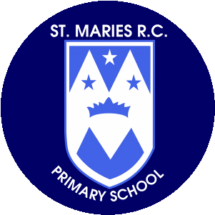+

**Year 1**

**Spring Term 1**

**January-April 25**

**Music**

In music this half term children will, compose word patterns in groups and melodies in pairs using mi-re-do (E-D-C). Compose musical sound effects and short sequences of sounds in response to a stimulus. Improvise question-and answer conversations using percussion instruments.

**Computing**

The children will be learning will be introduced to basic programming concepts. They will learn to give simple instructions to control actions, create algorithms, and explore patterns using age-appropriate tools and resources. This will help develop their problem-solving and logical thinking skills in a fun,

**Mathematics**

Children will focus on numbers up to 20, learning addition and subtraction strategies. They will explore number bonds, understanding how numbers can be combined or broken apart. This will help build their confidence in solving simple mathematical problems and developing number sense.

**Art and Design**

**Design Technology**

The children will be will explore primary colours—red, blue, and yellow. They will learn how to mix these colours to create new ones, understand their significance in art, and experiment with using primary colours in their own creative drawings and paintings.

**P.S.H.E.**

Through ‘My Happy Mind’, the children will be will explore the concept of gratitude. They will learn to recognize and express thankfulness for the people, experiences, and things around them. Activities will focus on kindness, reflection, and how showing appreciation positively impacts relationships and emotional well-being.

**Geography**

This half term we will be investigating the history of England’s monarchs, discovering famous kings and queens like Henry VIII and Elizabeth I. They will explore the roles of monarchs, key events during their reigns, and how these figures shaped England’s history.

**Religious Education – To Know You More Clearly**

During this half term the children will learn about the presentation of Jesus at the temple. They will explore the story from the Bible, understanding its significance in Christian faith. The lesson will focus on the importance of family, faith, and the rituals surrounding Jesus' early life.

**English**

The children will read Traction Man is Here, Out and About, and poems from The Puffin Book of Fantastic First Poems. They will focus on essential writing skills, such as using finger spaces, capital letters for names, full stops, exclamation marks, correct letter formation, and combining words to form sentences.

**Science**

This half term we will explore the topic of animals, including humans. They will learn about different types of animals, their basic needs, life cycles, and how humans grow and stay healthy. The focus will be on understanding the similarities and differences between species.

**Thank you for your support.**

**Miss Kirby**

**Homework**

Please encourage your child to read as often as possible and write a comment in their reading record book.

Spellings will be sent home on Fridays for our test on a Monday the following week – please encourage your child to learn them. All spellings are also on our class page.

**Physical Education**

P.E. this half term will be on Mondays and Fridays.

We will be focusing on mastering basic movements including running, jumping, throwing and catching, as well as developing balance, agility and co-ordination, and begin to apply these in a range of fun activities.