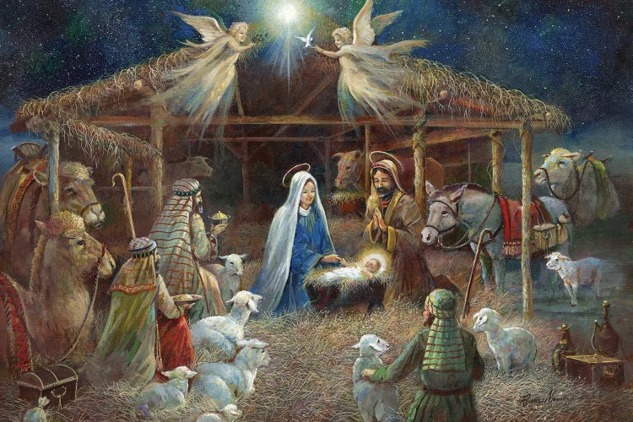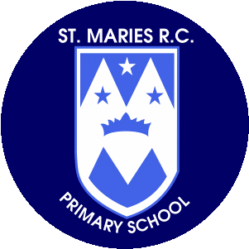

**Religious Education**

Our branch this term is ‘Prophecy and Promise’. The children will be introduced to Nativity story. The children will learn about the annunciation, Mary and Joseph’s Journey to Bethlehem, the birth of baby Jesus and what followed. We will also be celebrating advent and getting ready for Christmas. Children will learn about the advent wreath and its symbolism.

**Personal, Social and Emotional Development**

Our ‘My Happy Mind’ topic this half term will be ‘Celebrate’. During this topic we will be focusing on three key areas. First, that we all have things about us that are special, these are called character strengths. Next the children will be learning how we can use our character strengths to help us to be our best and finally considering how we feel when we use our character strengths.

**Mathematics** In our Maths sessions this half term will be building upon our learning from last term. We will still be focusing on counting using a 1-1 correspondence and number songs but we will be progressing onto comparing amounts using mathematical vocabulary – more, less, fewer and the same. The children will then be moving onto comparing size, mass and capacity. Finally the children will start looking at pattern, commenting on what they notice.

**Physical Development**

The children will be taking part in daily Squiggle or Dough Disco sessions. Squiggle uses dance and large movements to help children develop the fine motor control for writing. Dough Disco focuses solely on their fine motor skills. We will also be focusing on their gross motor skills. This term we will be working on; putting on our own coat, running with control, changing direction, balancing, walking up and downstairs with alternating feet, jumping and climbing.

**Understanding the World** This half term we will be focusing on Autumn and the changes that happen during this season. The children will be encouraged to observe changes whilst outdoors and notice differences in the weather and the environment. This will link to our focus of exploring natural materials using all of our senses. We will be observing lots of different natural materials, discussing their properties and using them in our play and for our artwork.

**Communication and Language**

The children will become familiar with following our daily routine by listening and paying attention to what is happening around them. The children will take part in a range of listening games which will help to develop their listening and understanding skills. We will be sharing lots of stories and nursery rhymes, encouraging the children to join in with the rhymes and actions.

**Literacy**

Children will spend time daily listening to and sharing a wide range of stories, rhymes and songs. Our key texts this term are Owl Babies, The Jolly Postman and

The Nativity.

The children will have a wide range of mark making opportunities which will encourage them to begin to make marks and give meaning to the marks that they make. They will be encouraged to recognise and write their name independently. In our phonics sessions the children will begin to develop and focus on their listening skills through sound discrimination. We will be focusing on rhythm and rhyme.

**Expressive Arts and Design**

This half term children will be introduced to our painting and creative stations. In the run up to Christmas the children will be creating Christmas crafts and making winter pictures. They will continue to use natural materials to create artwork linked to our UTW topic.

Children will be learning nursery rhymes and will be encouraged to join in with the songs and actions. We will be using body percussion and some simple musical instruments such as a tambourine, maracas, glockenspiel, castanets and wood blocks.

**Thank you for your continued support.**

**Miss Price, Miss Whitby & Mrs Fisher**

**Nursery**

**Autumn Term 2**

**November- December 2024**